LATA Foundation emergency funding in response to COVID-19

in partnership with Canning House

The LATA Foundation is jointly funding the following 6 projects with Canning House in response to the Covid-19 Pandemic:

Supplying PPE for midwives serving rural communities in Guatemala via Maya Midwifery
(The LATA Foundation and Canning House have jointly donated a total of £2500.00)

Based in Quetzaltenango, Guatemala, Mayan Midwifery International provides medical equipment for midwives serving rural communities. The equipment enables the midwives, who are often the only contact that families have with a health carer who speaks their dialect, essential services in rural areas of the highlands.

The funds donated by the LATA Foundation and Canning House will continue to supply PPE, gloves, masks and the ingredients to make large quantities of hand sanitizer to 71 midwives in five communities. The midwives provide mobile clinics, pre-natal and post-natal checks to hundreds of pregnant women in the communities and at their purpose built birthing centre.

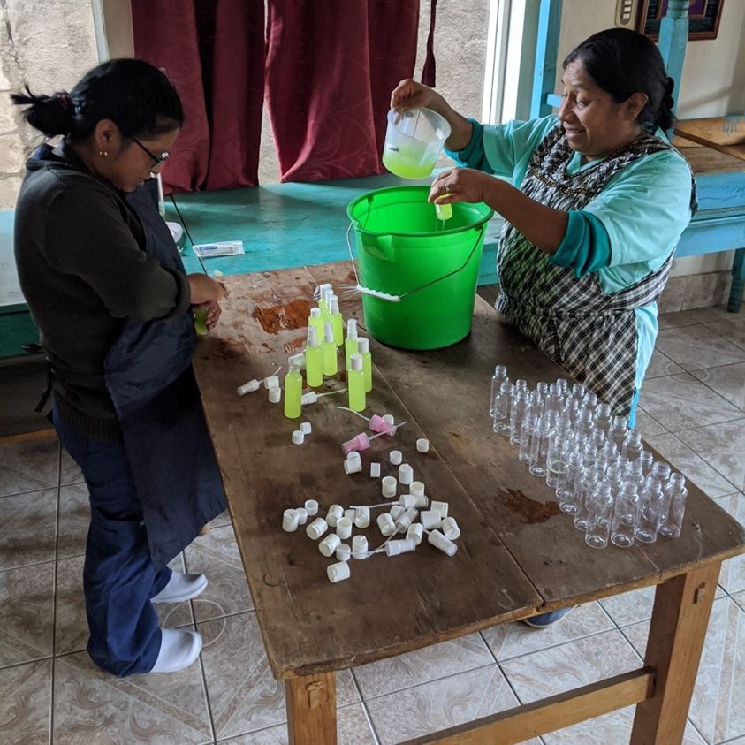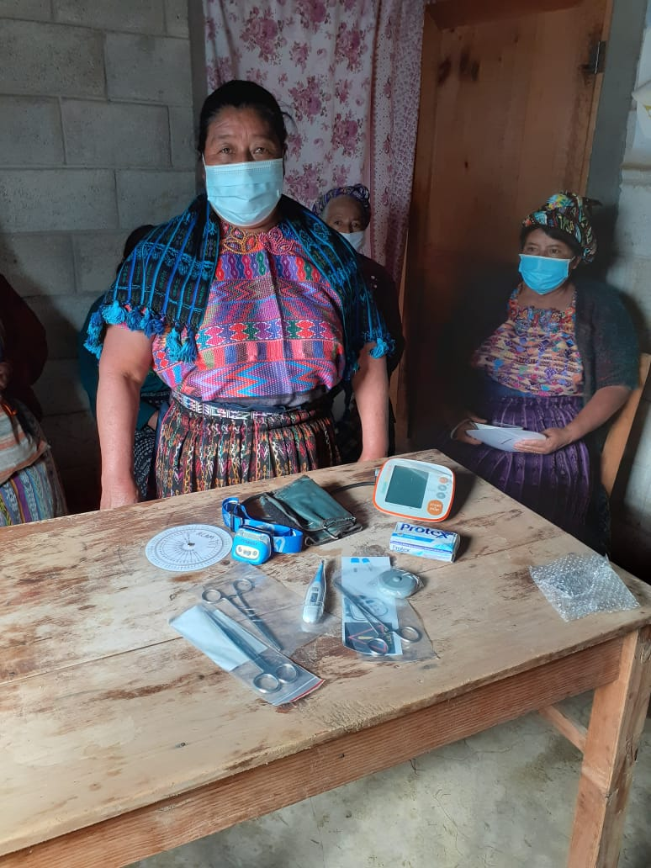

Supporting street children in Santa Cruz, Bolivia
(The LATA Foundation and Canning House have jointly donated a total of £3000.00)

Friends of Alalay, Santa Cruz, directly supports the Alalay Foundation, which was started in the early 1990’s by a 19-year-old Bolivian student who passed street children every day on her way to university and was determined to do something to help. Alalay rescues children from the streets and offers them a loving environment living together in family cabins. Alalay also feeds, clothes and educates the children and encourages them in their future working lives.

Funds from the LATA Foundation have been donated to the Alalay Foundation to enable them to pay for medical support and transportation required for the staff and children who were impacted directly or indirectly from the virus. The emergency funds donated by the LATA Foundation and Canning House will continue to support this in addition to the purchase of food, hygiene and cleaning products, benefitting approximately 100 children.

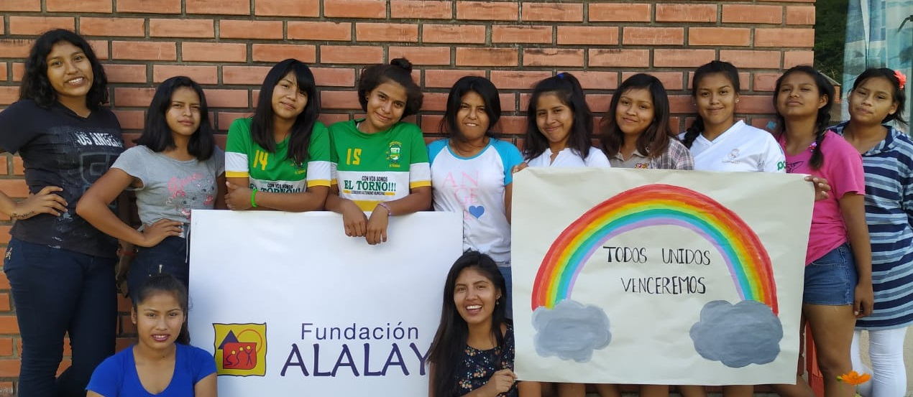

Supporting female entrepreneurs in Managua, Nicaragua
(The LATA Foundation and Canning House have jointly donated a total of £2500.00)

XtraOrdinary Women supports women from low income and high-risk environments in Nicaragua with free training, emotional support and job placement programmes, as well as support to set up their own small businesses. The programmes provide tools to help women become economically independent and break the cycle of poverty. In March, the LATA Foundation funded XtraOrdinary Women’s inaugural Bootcamp for Entrepreneurs, which lasted for 3 months and was completed successfully by 25 women. Although the course armed them with skills to grow their small businesses, Covid posed additional financial and logistical challenges. Extra funds have been donated to cover additional business mentoring to help the women adapt their business plans accordingly. We have also supplied them with cleaning products to protect their homes, businesses and families from the virus.

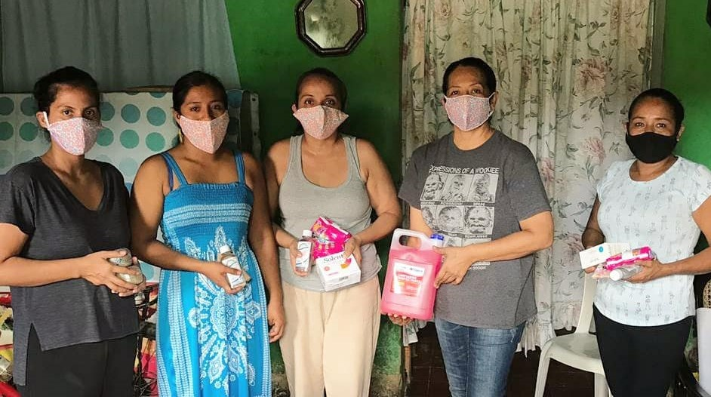

Supporting female artisans in Duque de Caixas, Brazil
(The LATA Foundation and Canning House have jointly donated a total of £2500.00)

Sinal do Vale is a charity and learning centre located in Duque de Caxias in the state of Rio de Janeiro, Brazil. The aim of the organisation is to encourage and support sustainable policies and the regeneration of communities, food systems and forests through education. The Covid-19 grant allowed Sinal do Vale to purchase food parcels for between 35-40 local artisans who had received training from Sinal do Vale and have been left unable to sell their wares due to the pandemic.

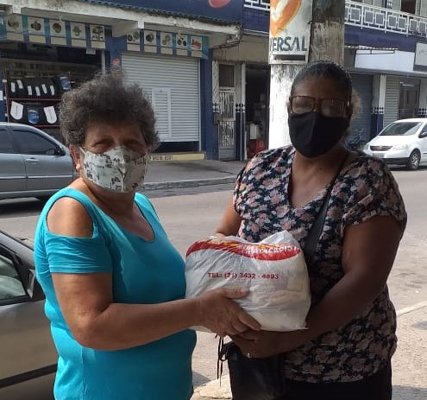

Supporting medical projects throughout Venezuela
(The LATA Foundation and Canning House have jointly donated a total of £2500.00)
Healing Venezuela is a volunteer-run organisation which aims to alleviate the health crisis in Venezuela offering medical assistance in an impartial, neutral and compassionate way. With the COVID19 crisis, the situation has significantly worsened in Venezuela. The country is ill-prepared to deal with a pandemic and reports from their doctors on the ground are distressing. The number of cases and deaths reported by the government are relatively low, but this is likely to be due to gross underreporting. Tragically, they estimate that 28% of the total deaths are health professionals. In April 2020, Healing Venezuela and the LATA Foundation fund-matched in order to buy and distribute PPE to hospitals, which were designated to provide care for COVID19 patients (Sentinel Hospitals), and to several health centres with whom they have been working for the last 3 years. 500 N95 masks and 120 shields where distributed to the junior doctors who are part of Healing Venezuela’s sponsorship programme. The extra emergency funds donated in partnership with Canning House will help further this work.
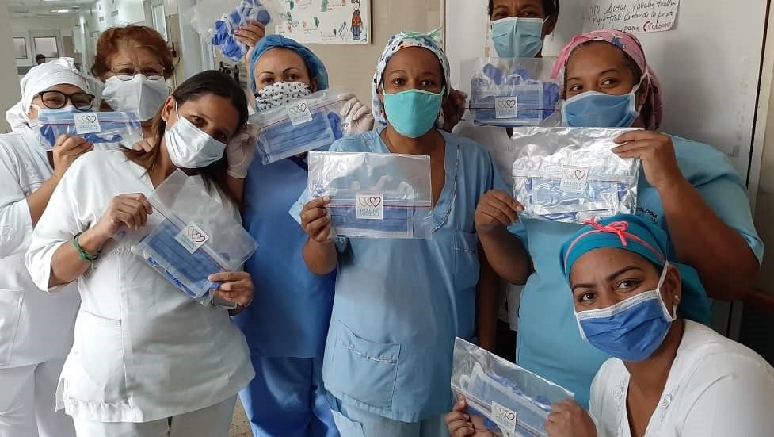

Supplying PPE and First-aid kits for rural Afro-Caribbean communities
(The LATA Foundation and Canning House have jointly donated a total of £2500.00)

Chilldren Change Colombia tackles the issues of sexual and gender-based violence, commercial sexual exploitation, and the forced recruitment of minors into armed groups. During the pandemic however the charity appealed for PPE and first aid kits for communities located along the banks of the isolated San Juan River. This area has a heavy presence of illegal armed groups, and there are death threats if anyone gets the virus. The grant supplied each community to have PPE and medical provisions.

