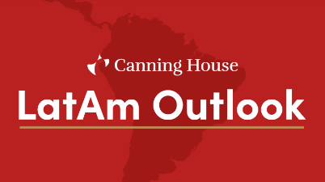
PRESS RELEASE – 18 / 02 / 2020 – London
Canning House’s LatAm Outlook identifies the forces shaping Latin America in years to come
On 11 March, Canning House – in partnership with Ipsos, Itaú Bank, Control Risks, and FT Latin America editor Michael Stott – will launch the Canning House LatAm Outlook.
The Canning House LatAm Outlook is
- a forward-looking, scenario-based overview of the forces shaping Latin America’s political, economic, social and business environment
- an assessment of their likely impact on society, financial and economic development, and trade and investment over the next 5 years and beyond, through the lens of the region’s 6 major economies (Argentina, Brazil, Chile, Colombia, Mexico and Peru)
It will address key questions such as: What does populism mean for Latin America? Will growth return to the continent? Can Bolsonaro's reforms revive Brazil? What are the prospects for AMLO's Fourth Transformation of Mexico?
Its target audience includes businesses, government ministers and parliamentarians, policymakers and regulators, opinion-formers, think-tanks, and media representatives – in the UK, EU, USA and Latin America.
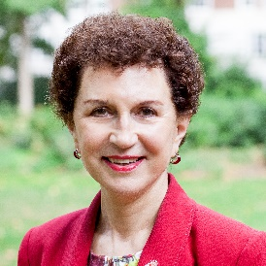
“The Canning House LatAm Outlook is an indispensable conference for existing businesses seeking to stay resilient in the face of potential changes in Latin America”
– Cristina Cortes, CEO, Canning House

“Vital for getting beneath the headlines to what is really going on in Latin America.” – Michael Stott, Latin America editor, FT
“Takes the pulse of social trends and assesses their impact on the health of the body politic.” – Alex Gronberger, CEO Latin America, Ipsos
“An essential conference for any business wrestling with decisions about whether or not to trade, invest or offer financial services to the major economies of Latin America” – Mario Mesquita, Chief Economist, Itaú Bank
“Crucial intelligence for any business with Latin American interests.” – Oliver Wack, Partner, Control Risks
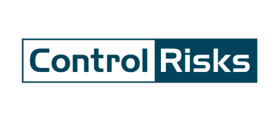
In partnership with

Further Information
Event details: 11 March 2020, 08:45 to 14:00, at the Four Seasons Hotel, Park Lane, W1J 7DR.
For more information about this event, please visit https://www.canninghouse.org/events/latam-outlook, or contact our Press team (details below).

Canning House:
- For over 75 years, Canning House’s Mission has been to build understanding and relationships between the UK, Latin America & Iberia. We are the UK’s leading forum for contacts, thought-leadership and pragmatic debate on Latin American political, economic and social trends and issues, and business risks and opportunities.
Ipsos:
- Ipsos is a leading global survey-based market research company founded in 1975, owned and managed by research professionals. Ipsos helps interpret, simulate, and anticipate the needs and responses of consumers, customers, and citizens around the world. It is the world’s third largest research agency, and as of 2014, Ipsos has offices in 88 countries, employing 16,530 people.
Itaú Bank:
- Itaú BBA is Latin America’s largest Corporate & Investment Bank and is part of the Itaú Unibanco group, one of the world’s largest financial conglomerates. It is the 10th largest bank in the world by market value, and is listed on the São Paulo and New York stock exchanges.
Control Risks:
- Control Risks is a global specialist risk consulting firm that helps clients create organizations that are secure, compliant and resilient in an age of ever-changing risk and connectivity. Its experts across 36 offices help clients investigate wrongdoing and resolve crises, and provide the insight and intelligence companies need to realize opportunities and grow.
Michael Stott, Financial Times:
- Michael Stott is the Latin America editor of the Financial Times based in London and has reported from more than 60 countries in more than three decades as a foreign correspondent and news executive. He covered Latin America between 1990-1998, living in Brazil, Colombia and Mexico. Michael graduated from Cambridge University with an MA in Modern Languages and speaks fluent Spanish, Portuguese, French, German and Russian.

To find out more, please visit our website https://www.canninghouse.org/.
ALL PRESS ENQUIRIES: Angela Bourderye-Muñoz | Current Affairs, Culture & Communications Manager | angela.bourderyemunoz@canninghouse.org |

